**Practical no.-**16

**Title:** Develop a program to implement Date and Time Picker.

**Roll No.:**15 **Batch-** A **Date of Performance:** 26/02/2024

**activity_main.xml**

<?xml version="1.0" encoding="utf-8"?>

<AbsoluteLayout xmlns:android="http://schemas.android.com/apk/res/android"

xmlns:app="http://schemas.android.com/apk/res-auto"

xmlns:tools="http://schemas.android.com/tools"

android:layout_width="match_parent"

android:layout_height="match_parent"

tools:context=".MainActivity">

<TextView

android:layout_width="wrap_content"

android:layout_height="wrap_content"

android:layout_x="108dp"

android:layout_y="17dp"

android:text="AM/PM"

android:textSize="20dp"

android:textStyle="bold" />

<TextView

android:layout_width="wrap_content"

android:layout_height="wrap_content"

android:layout_x="108dp"

android:layout_y="196dp"

android:text="24 Hours"

android:textSize="20dp"

android:textStyle="bold" />

<TimePicker

android:id="@+id/timePickerAMPM"

android:layout_width="wrap_content"

android:layout_height="161dp"

android:layout_x="27dp"

android:layout_y="45dp"

android:timePickerMode="spinner" />

<NumberPicker

android:id="@+id/hoursPicker24"

android:layout_width="wrap_content"

android:layout_height="151dp"

android:layout_x="70dp"

android:layout_y="227dp"/>

<NumberPicker

android:id="@+id/minutesPicker24"

android:layout_width="wrap_content"

android:layout_height="148dp"

android:layout_x="161dp"

android:layout_y="229dp" />

<TimePicker

android:id="@+id/timePickerClockMode"

android:layout_width="250dp"

android:layout_height="340dp"

android:layout_x="40dp"

android:layout_y="379dp"

android:timePickerMode="clock" />

<Button

android:id="@+id/display_time_button"

android:layout_width="wrap_content"

android:layout_height="wrap_content"

android:layout_x="291dp"

android:layout_y="643dp"

android:text="Display Time" />

</AbsoluteLayout>

**MainActivity.java**

package com.example.pract_161timepicker;

import android.os.Bundle;

import android.view.View;

import android.widget.Button;

import android.widget.NumberPicker;

import android.widget.TimePicker;

import android.widget.Toast;

import androidx.appcompat.app.AppCompatActivity;

public class MainActivity extends AppCompatActivity {

private NumberPicker hoursPicker24, minutesPicker24;

private TimePicker timePickerAMPM, timePickerClockMode;

private Button displayTimeButton;

@Override

protected void onCreate(Bundle savedInstanceState) {

super.onCreate(savedInstanceState);

setContentView(R.layout.activity_main);

hoursPicker24 = findViewById(R.id.hoursPicker24);

minutesPicker24 = findViewById(R.id.minutesPicker24);

timePickerAMPM = findViewById(R.id.timePickerAMPM);

timePickerClockMode = findViewById(R.id.timePickerClockMode);

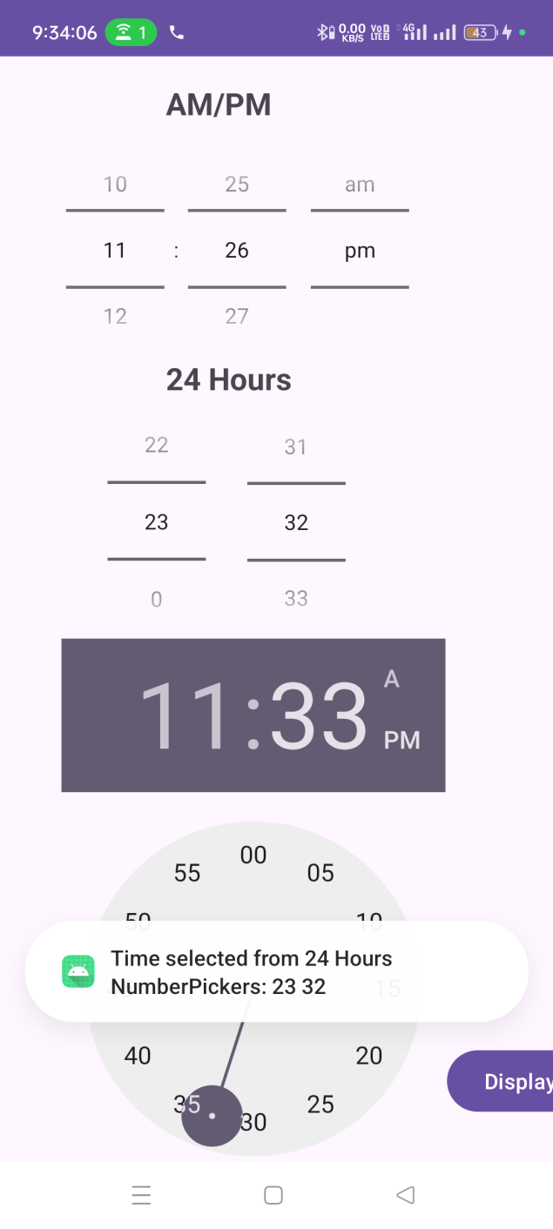 displayTimeButton = findViewById(R.id.display_time_button);

hoursPicker24.setMinValue(0);

hoursPicker24.setMaxValue(23);

minutesPicker24.setMinValue(0);

minutesPicker24.setMaxValue(59);

displayTimeButton.setOnClickListener(new View.OnClickListener() {

@Override

public void onClick(View v) {

int hour24 = hoursPicker24.getValue();

int minute24 = minutesPicker24.getValue();

String time24 = "Time selected from 24 Hours NumberPickers: " + String.format("%02d", hour24) + " " + String.format("%02d", minute24);

int hourAMPM = timePickerAMPM.getCurrentHour();

int minuteAMPM = timePickerAMPM.getCurrentMinute();

String timeAMPM = "Time selected from AM/PM TimePicker: " + hourAMPM + ":" + minuteAMPM;

int hourClockMode = timePickerClockMode.getCurrentHour();

int minuteClockMode = timePickerClockMode.getCurrentMinute();

String timeClockMode = "Time selected from Clock Mode TimePicker: " + hourClockMode + ":" + minuteClockMode;

Toast.makeText(getApplicationContext(), time24, Toast.LENGTH_SHORT).show();

Toast.makeText(getApplicationContext(), timeAMPM, Toast.LENGTH_SHORT).show();

Toast.makeText(getApplicationContext(), timeClockMode, Toast.LENGTH_SHORT).show();

}

});

}

}

**activity_main.xml**

<?xml version="1.0" encoding="utf-8"?>

<AbsoluteLayout xmlns:android="http://schemas.android.com/apk/res/android"

android:layout_width="match_parent"

android:layout_height="match_parent">

<TextView

android:id="@+id/dateTextView"

android:layout_width="wrap_content"

android:layout_height="wrap_content"

android:layout_x="10dp"

android:layout_y="119dp"

android:text="Selected Date="

android:textSize="20dp" />

<Button

android:id="@+id/selectDateButton"

android:layout_width="wrap_content"

android:layout_height="wrap_content"

android:layout_x="39dp"

android:layout_y="220dp"

android:text="Select Date" />

<TextView

android:id="@+id/timeTextView"

android:layout_width="wrap_content"

android:layout_height="wrap_content"

android:layout_x="12dp"

android:layout_y="158dp"

android:text="Selected Time="

android:textSize="20dp" />

<Button

android:id="@+id/selectTimeButton"

android:layout_width="wrap_content"

android:layout_height="wrap_content"

android:layout_x="176dp"

android:layout_y="221dp"

android:text="Select Time" />

</AbsoluteLayout>

**MainActivity.java**

package com.example.pract_162datetime;

import androidx.appcompat.app.AppCompatActivity;

import android.app.DatePickerDialog;

import android.app.TimePickerDialog;

import android.os.Bundle;

import android.view.View;

import android.widget.Button;

import android.widget.DatePicker;

import android.widget.TextView;

import android.widget.TimePicker;

import java.text.SimpleDateFormat;

import java.util.Calendar;

import java.util.Locale;

public class MainActivity extends AppCompatActivity {

private TextView dateTextView, timeTextView;

private Button selectDateButton, selectTimeButton;

@Override

protected void onCreate(Bundle savedInstanceState) {

super.onCreate(savedInstanceState);

setContentView(R.layout.activity_main);

dateTextView = findViewById(R.id.dateTextView);

timeTextView = findViewById(R.id.timeTextView);

selectDateButton = findViewById(R.id.selectDateButton);

selectTimeButton = findViewById(R.id.selectTimeButton);

selectDateButton.setOnClickListener(new View.OnClickListener() {

@Override

public void onClick(View v) {

showDatePicker();

}

});

selectTimeButton.setOnClickListener(new View.OnClickListener() {

@Override

public void onClick(View v) {

showTimePicker();

}

});

}

private void showDatePicker() {

final Calendar calendar = Calendar.getInstance();

int year = calendar.get(Calendar.YEAR);

int month = calendar.get(Calendar.MONTH);

int dayOfMonth = calendar.get(Calendar.DAY_OF_MONTH);

DatePickerDialog datePickerDialog = new DatePickerDialog(MainActivity.this,

new DatePickerDialog.OnDateSetListener() {

@Override

public void onDateSet(DatePicker view, int year, int monthOfYear, int dayOfMonth) {

calendar.set(Calendar.YEAR, year);

calendar.set(Calendar.MONTH, monthOfYear);

calendar.set(Calendar.DAY_OF_MONTH, dayOfMonth);

SimpleDateFormat sdf = new SimpleDateFormat("dd/MM/yyyy", Locale.getDefault());

String selectedDate = sdf.format(calendar.getTime());

dateTextView.setText("Selected Date: " + selectedDate);

}

}, year, month, dayOfMonth);

datePickerDialog.show();

}

private void showTimePicker() {

final Calendar calendar = Calendar.getInstance();

int hourOfDay = calendar.get(Calendar.HOUR_OF_DAY);

int minute = calendar.get(Calendar.MINUTE);

TimePickerDialog timePickerDialog = new TimePickerDialog(MainActivity.this,

new TimePickerDialog.OnTimeSetListener() {

@Override

public void onTimeSet(TimePicker view, int hourOfDay, int minute) {

calendar.set(Calendar.HOUR_OF_DAY, hourOfDay);

calendar.set(Calendar.MINUTE, minute);

SimpleDateFormat sdf = new SimpleDateFormat("HH:mm", Locale.getDefault());

String selectedTime = sdf.format(calendar.getTime());

timeTextView.setText("Selected Time: " + selectedTime);

}

}, hourOfDay, minute, true);

timePickerDialog.show();

 

